**Business Structure**

Describe the different **functional areas** that appear in your company

**- Information and Technology:** almost all businesses nowadays make use of computers and information systems. The Information Technology (IT) Department is responsible for the architecture, hardware, software and networking of computers in a business. Their main tasks include data management, development and operation of network and website maintenance.

- M**arketing area:** buying and selling.

**- Finance and accounting area:** search and management of capitals that allow investments and all the accounting functions of the company.

**- Human resources area:** personnel functions, prevention of occupational risks.

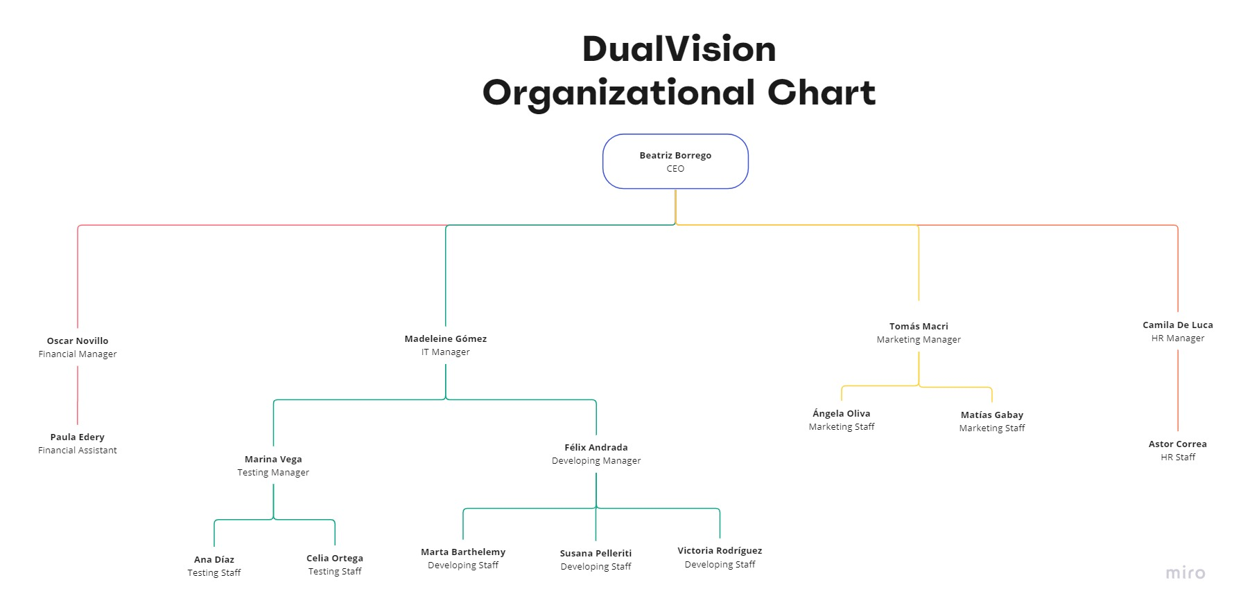Draw an **organizational chart** that reflects the structure of your company